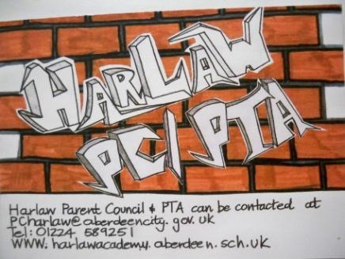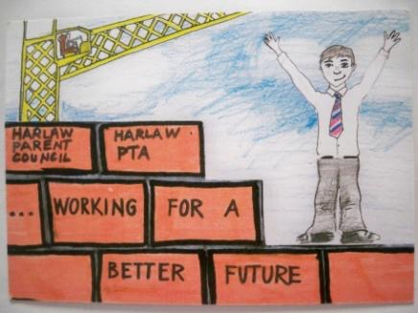

HARLAW ACADEMY PARENT COUNCIL MEETING
Thursday 27th April 2017 at 7pm Harlaw Academy

AGENDA
- Apologies
- Minutes of last meeting 16th February 2017
3. Chairperson’s report
4. School Report
Wider Achievement and Opportunities Mr Tom Whyte and Mr Paul O’Connor
Pupil Report - input to school improvement – see attached paper
5. Treasurer’s Report
6. PTA report
7. Former Pupil Report
8. Dates of next meetings 8/6/17 (clash with prize giving?)
9. A.O.B

